**Now Mobile POC - Case Management**

**Customer Service Mobile Plugin Activation**

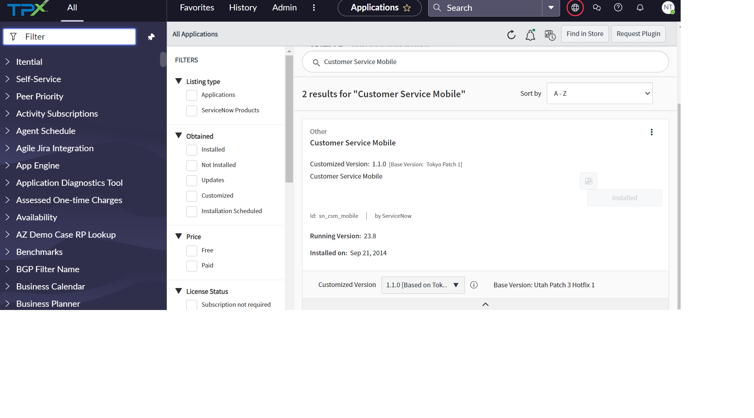

**OOB Available Screen**

* This screen will be available for agent and manager.
* These cases have been showing data from case table.
* For showing data from our case type, we must create our own screen as per each agent roles.

**List View and Form View of New Cases**   
  
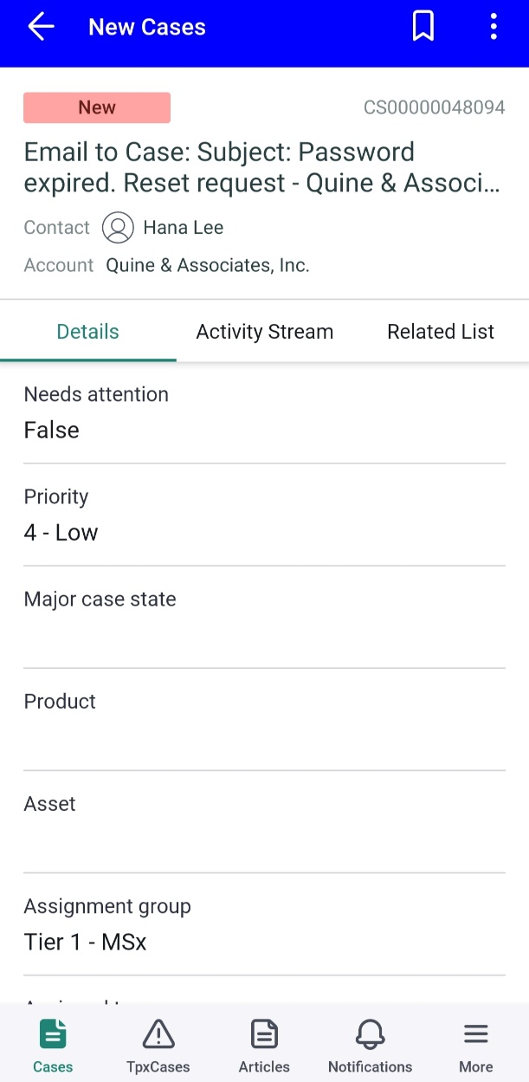

**Custom Built – Applet Launcher and UI Section**

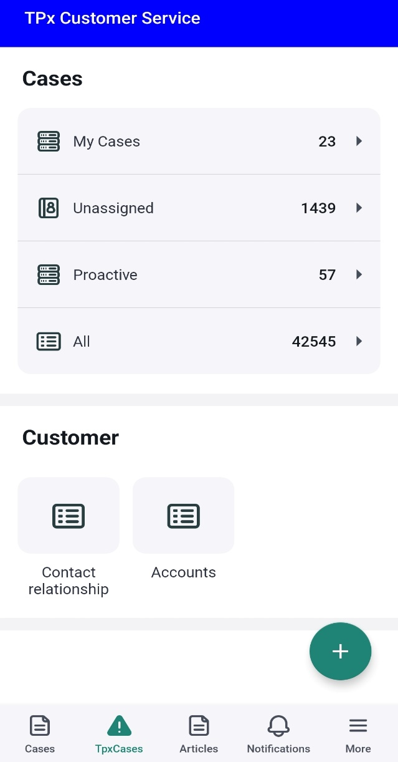

**List View and Form View of My Cases**  
  
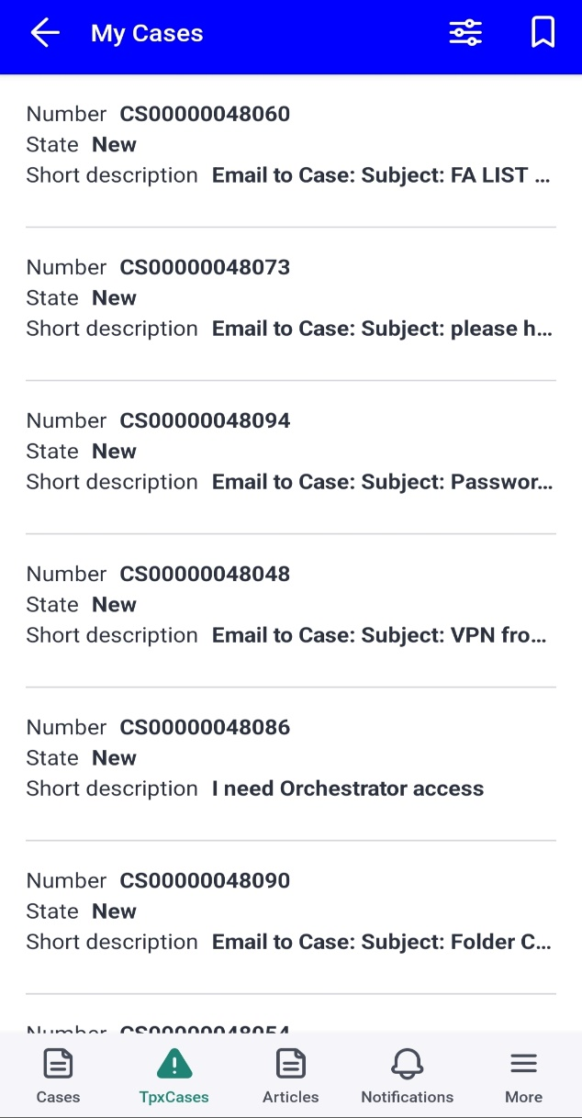 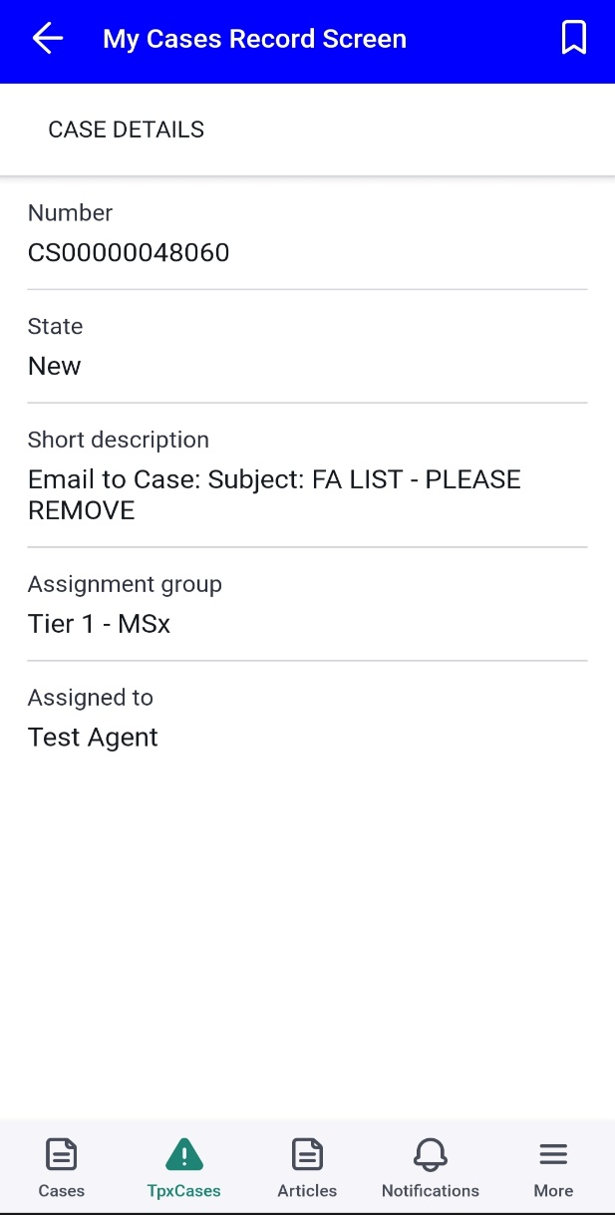

**List View and Form View of Unassigned Cases**   
  
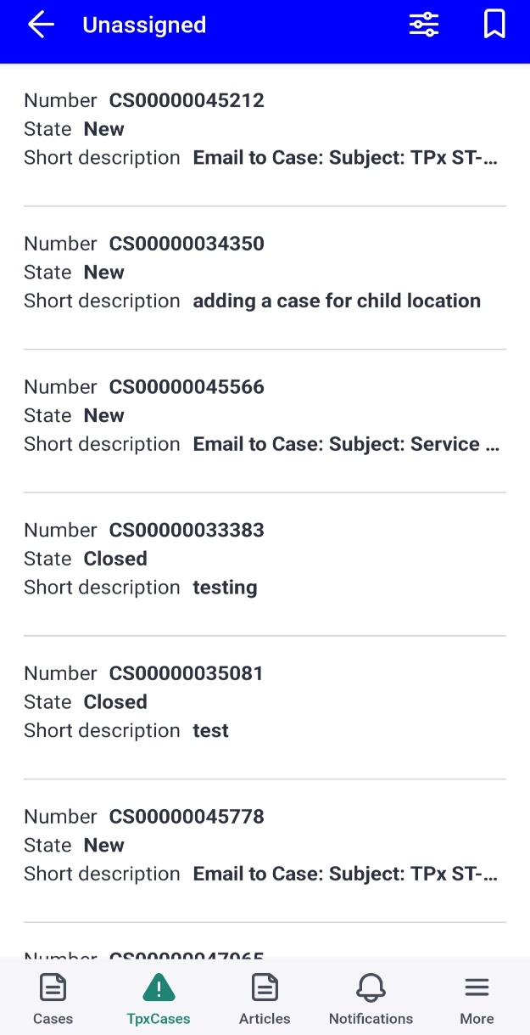 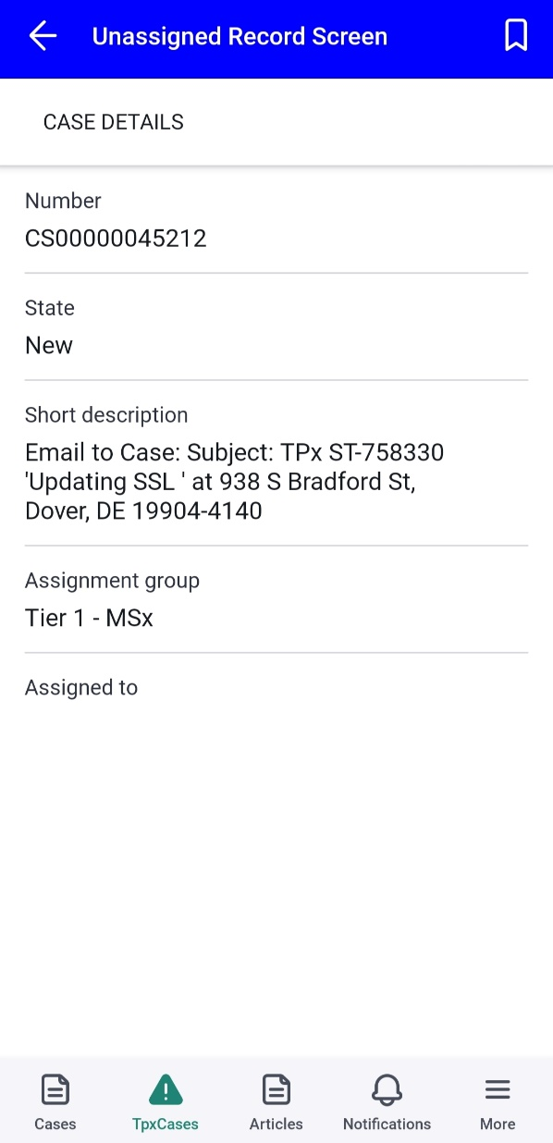

**List View and Form View of Proactive Cases**   
  
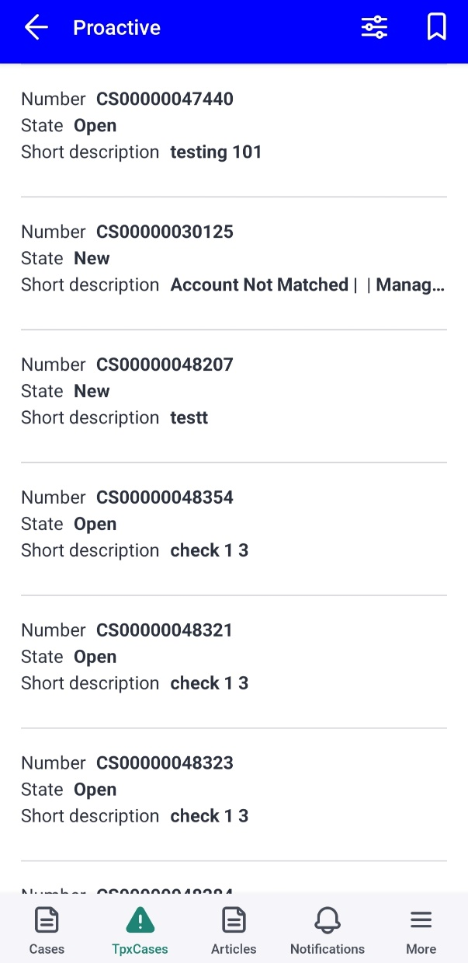

**List View and Form View of All Cases**  
  
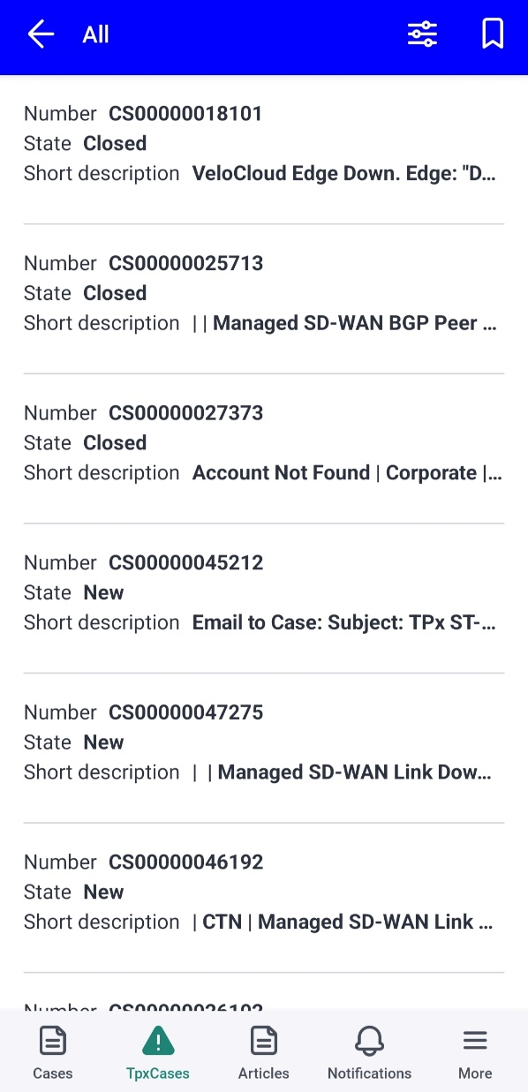

**Contact Relationship and Accounts details**  
  
Knowledge Article Full View with other features**

**Notifications and more**   
  
**Features of mobile agent app**

* Provide interface to agent to triage, address and resolve cases.
* Offline mode
* Location tracking feature

**Terminologies**

